Chapter 1 Vision & Strategy

Chapter 1 Vision & Strategy 1
Where we are – Oxford’s Opportunities and Challenges 1
Where we are going – Vision for Oxford in 2040 3
Oxford will be a healthy and inclusive city to live in 4
Oxford will be a fair and prosperous city with a globally important role in learning, knowledge and innovation 6
Oxford will be a green and biodiverse city that is resilient to climate change 7
Oxford will be a city that utilises its resources with care, protects the air, water and soil and aims for net zero carbon 8
Oxford will be a city that respects its heritage and fosters design of the highest quality 10
Oxford will be a liveable city with strong communities and opportunities for all 11
Overarching threads 12
Spatial Strategy and Presumption in Favour of Sustainable Development 14
Policy S1: Spatial Strategy and Presumption in Favour of Sustainable Development 15
Design Code and Guidance 17
Policy S2: Design Code and Guidance 19
Policy S3: Infrastructure Delivery in New Development 20
Policy S4: Plan Viability 22

Where we are – Oxford’s Opportunities and Challenges

1.1 Oxford is an attractive place to live, work, study and visit and is home to a diverse range of communities. Its environment is characterised by a wealth of heritage that has built up over centuries of settlement and by the many areas of high quality green and blue spaces that harbour a variety of ecologically important habitats. The city has a broad, multi-faceted and active economy, with one of the highest concentrations of knowledge intensive businesses in the UK. This is enhanced by its historic role as a world-renowned seat of learning with two universities and a strong research and innovation sector.
1.2 However, this attractiveness and success has brought with it challenges for our environment and the people who live and work in the city. High demand for land results in high land values; congestion on the city’s roads makes movement difficult and exacerbates poor air quality in certain areas; and the supporting infrastructure has struggled to keep pace with a changing and growing city. These challenges are intensified by national and international pressures such as rising build costs for new development, a chronic undersupply of housing, climate change and energy insecurity. The role of this new Local Plan is to build upon the positive aspects that make the city so special, whilst also seeking to address the challenges we face through positive planning policies to ensure the optimum outcomes for the environment and its residents, businesses, education, and health institutions.

Table 1.1: Oxford’s strengths, weaknesses, opportunities and threats
Summarise into a graphic by designer

Natural Environment
Strengths
The city hosts a diversity of significant habitats and biodiversity interconnected by a network of blue corridors such as the rivers, the canal, and smaller streams. Publicly accessible open spaces provide many functions that support people’s wellbeing, including outdoor sports.
- 117 playing pitches
- 35 allotments
- 248,200 trees
- 22.3% of the city has canopy cover
- 12 Sites of Special Scientific Interest
- 15 historic parks and gardens
- 2 rivers – the Cherwell and the Thames
Weaknesses
Fragmentation has occurred over time which can weaken ecosystems. Some parts of the city have less access to public green spaces nearby than others. Limited opportunities to create new green, open space.
Opportunities
Green Infrastructure is essential to adapting to climate change, for example as flood storage and by creating shade. Green Infrastructure is multi-functional – able to contribute to many other objectives essential for sustainability e.g., health and wellbeing, carbon sequestration, setting for heritage, economic growth. Development will provide opportunities to recreate nature connections, enhance biodiversity and to bring more green infrastructure into brownfield sites.
Threats
Climate change is likely to impact species and ecosystems. Some ecosystems are sensitive to the impacts of development. Development pressure and a growing population could put increasing demands on the city’s open spaces.
- 5,000 homes at risk of flooding
- 10% increase in extreme weather by 2050

Built Environment
Strengths
Oxford has a rich and valued built heritage of strong and distinctive character. The city is compact with very good access to local centres and the city centre by sustainable modes.
- Buildings from every period since 11th Century
- 10 scheduled monuments
- 18 conservation areas
- 1500 listed buildings
Weaknesses
Despite the quality of the built environment in some areas, there are other parts of the city where developments have not made the best use of land or have not created successful places. Some areas do not enable easy and safe access to services and facilities. Traffic congestion can be high, which can make the environment feel less safe for cyclists and pedestrians and make public transport less reliable, as well as creating more air pollution and wasting time. There are some barriers to moving around parts of the city, such as watercourses and busy roads. Much of our current building stock will require improvements or retrofitting to meet net zero objectives.
Opportunities
The compact nature of the city and the wide range of facilities and services mean that there are great opportunities for sustainable and healthy lifestyles, which can be enhanced further by improvements to existing routes or new connections, such as new bridges.
Threats
New development that generates car use would exacerbate problems with congestion, undermine the attractiveness of more sustainable modes and how easily and happily people can access goods and services. Additional car traffic would also affect the quality and enjoyment of the streets and spaces.

Community Culture and Living
Strengths
Oxford’s city centre and distinctive district centres sit at the heart of local communities and ensure good access to important leisure, cultural, healthcare and education facilities. Oxford has diverse communities and a strong identity.
Weaknesses
There is a limited housing stock and high demand, limiting people’s access to decent homes in the city. There are pockets of housing deprivation. There are wide inequalities in the city, with some of the most and least deprived wards in the county sitting side-by-side in Oxford. The recent pandemic has exposed and exacerbated inequalities, which could take a long time to even out.
- 2,780 people households on housing register June 23
- 10.5% households in fuel poverty 2018
- 12% with limiting long-term illness or disability
- 1 out of 83 areas among the 10% most deprived in the UK, 12 areas in least 10% deprived in the UK
- 29% children live below poverty line
- 12.4 years lower life expectancy for females in Greater Leys than Wolvercote/Cutteslowe
- 38% increase in mental health referrals 2016-2020
Opportunities
The Local Plan’s policies are intended to facilitate the delivery of affordable housing and support high quality, sustainable design. In combination, these can support health and wellbeing, net zero and biodiversity objectives.
Threats
A growing economy can result in a side effect of putting more pressure on the housing market, exacerbating issues with affordability. The issues in the housing market will be difficult to resolve. Transient communities can be difficult to absorb into wider society. An ageing population puts more demands on healthcare provision, and attention needs to be given to designing the built environment to meet the needs of everyone.

Economy
Strengths
Oxford’s economy has strengths in research and development which are helping to find solutions to global problems, such as through development of the Astra Zeneca Covid-19 vaccine.
- Strong economy
- Major research, publishing, health sectors and the MINI Plant Oxford manufacturing plant
- £7.34bn contribution to national economy in 2017
- University of Oxford has more spin-outs than any other in the UK
- Youthful and well qualified population in and entering the workforce.
Weaknesses
There is a lack of high-quality office space in the city centre, where there is high demand. Some employment areas are harder to access compared to most of Oxford and do not make efficient use of land. There is a disparity in education and skills of the population and therefore in access to jobs. The compact nature of the city means that there is a limited housing stock, and this can lead to difficulties attracting and retaining staff, which affects the running of institutions and businesses.
Opportunities
Growth of green economy, more demand for technologies like heat pumps, solar PV could strengthen market, create job roles for people manufacturing and installing these technologies. More focus on ‘local’ businesses, produce/foods, as international challenges like pandemics and political instability compromise globalised markets and supply chains. Its youthful, dynamic population means it has a dynamic well qualified looking for new business opportunities, working in our schools, health care and both private and the public sector.

Threats
The links between the universities, the hospitals and private enterprise create opportunities for ground-breaking developments but even greater focus on highly skilled research and development risks disenfranchising some citizens. Greater automation in the manufacturing sector, shifts to online retail and changing job profiles/skills requirements could result in reducing available jobs particularly for lower skilled professions.

Where we are going – Vision for Oxford in 2040

1.2 This Local Plan for the period 2020 to 2040, supersedes the Local Plan 2036 and other relevant parts of the development plan including the Northern Gateway Area Action Plan. The vision for Oxford in 2040 seeks to address the strengths and challenges identified above. It is as follows:
In 2040 Oxford will be a healthy and inclusive city, with strong communities that benefit from equal opportunities for everyone, not only in access to housing, but to nature, employment, social and leisure opportunities and to healthcare. Oxford will be a city with a strong cultural identity, that respects our heritage, whilst maximising opportunities to look forwards to innovate, learn and enable businesses to prosper. The vision is one which supports research and development in the life sciences and health sectors which are and will provide solutions to global challenges. The environment will be central to everything we do; it will be more biodiverse, better connected and more resilient. We will utilise resources prudently whilst mitigating our impacts on the soil, water, and air. The city will be net zero carbon, whilst our communities, buildings and infrastructure will be resilient to the impacts of climate change and other emergencies.
1.3 The vision for the city in 2040 is divided into six themes which are illustrated in Figure 1. These include three themes based on the pillars of sustainability and three themes which fall at the intersections of those pillars. Taken together, the six themes represent what we consider to be a sustainable future for Oxford.

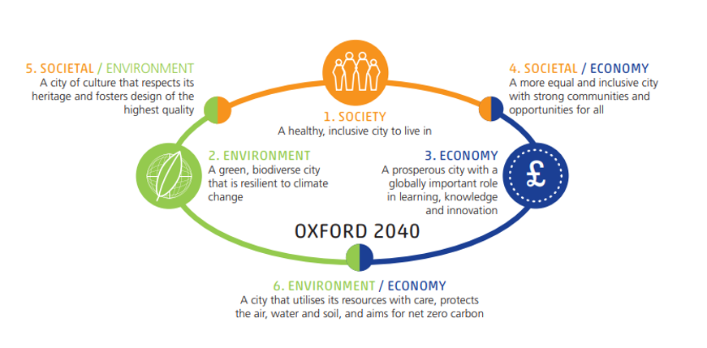
Figure 1.1: The six themes underpinning our vision for Oxford in 2040 – adapted from the three pillars of sustainability (society, economy and the environment)

Objectives and strategy
1.4 The objectives for the Plan set out in more detail how it seeks to meet the vision for the city in 2040. There are several objectives that build off each of the six themes identified above. There are overlaps between the themes and objectives and many could fit within several themes in practice.

Oxford will be a healthy and inclusive city to live in

- There is access to affordable, high-quality and healthy living accommodation for all.
- We have a built environment that supports and enables people to be physically and mentally healthy.
1.5 Oxford as a city is intrinsically a sustainable location for housing because of the access to services and facilities, work, leisure, community, and cultural opportunities. All areas of the city are accessible by sustainable means, and much of the city is within 400m to a 15 minute+ bus service, although there are opportunities for improvement and the Plan will support all opportunities to improve the public transport offer across the city.
1.6 However the physical land constraints mean there is a limited supply of housing in the city, which exacerbates inequalities by leading to high property prices and a limited supply of affordable housing. This is illustrated by the numbers of people waiting on the City Council housing register (2,780 people as at June 2023), and also the house prices: In September 2022 the median house price in Oxford was £445,775, with homes costing 12 times the median salary, meaning Oxford remains one of the least affordable places to buy in the country. Likewise, median rental prices in Oxford are £1,300 a month as of March 2023, which is significantly higher than the average for the South East of England. This means that many lower paid essential workers cannot afford to live in the city and then employers experience high staff turnover and vacancy rates which can affect their operation. This is particularly apparent in the city’s schools, hospitals, care homes, public transport services, the building industry, and the universities.
1.7 The Plan sets out a range of policies intended to tackle these issues: the overall priority use for new sites is to deliver homes to meet housing needs (including on some employment sites), whilst also ensuring that the infrastructure, employment, education, and health needs for the city are met. To support this, the Plan also sets out site allocation and Area of Focus policies which will help to give more certainty to communities and landowners about delivery of new homes, and to help ensure that the limited supply of new sites are used as efficiently as possible to help address housing need, with the highest densities directed to the city centre and district centres. The Plan also sets out ambitious policies to tackle the affordability of housing in Oxford; these include policies seeking affordable housing contributions from general housing, student accommodation, and older persons accommodation; as well as continuing the innovative employer-linked affordable housing policy, to enable key employers in Oxford, including the hospitals, to develop affordable housing on their own sites to help meet their staff’s needs.
1.8 It is also important that the right kind of homes are provided to meet identified needs, and to deliver mixed and balanced communities and avoid over-concentration of any one type of housing or sector of the community. As such the Plan sets out policies to guide the types, sizes, and tenures of new homes across the city, as well as locational strategies for new student accommodation and other specialist housing needs to help balance the need for those types of accommodation along with general housing.

Oxford will be a fair and prosperous city with a globally important role in learning, knowledge and innovation
- We continue to build on the city’s strengths in knowledge, healthcare and innovation.
- We continue to support the city’s recovery from the Covid-19 pandemic and build resilience to future pandemics and economic challenges/shocks.
- There are ongoing opportunities for education, learning and skills development.
1.9 Oxford’s economy is a key driver in the wider Oxfordshire economy, which in of itself made a £23bn pre-pandemic contribution to the national economy. The county’s wider economic vision and strategy is set out in a series of documents produced by the Oxfordshire Local Enterprise Partnership (OxLEP) in partnership with the Future Oxfordshire Partnership (formerly the Oxfordshire Growth Board). These documents include the Strategic Economic Plan (“SEP”) (which was endorsed by the City Council’s Executive Board (now Cabinet) in 2016), the Local Industrial Strategy (“LIS”) and its supporting Local Investment Plan (‘LIP”), which suggests that the county’s economic growth is likely to be approximately £1.2bn to 2030. It is worth noting that all of the Oxfordshire authorities are partners in the LIS as the Leaders of the Councils are on the OxLEP Board. In terms of the wider sub-regional economy, in January 2023 the government confirmed support for the locally led Oxford to Cambridge Pan Regional Partnership, which provides access to £2.5m of government funding for the delivery of the Partnership’s priorities in delivering sustainable growth and environmental enhancements for the region.
1.10 Oxford’s strength in knowledge, healthcare and innovation is supported and encouraged by the Plan’s strategy. Oxford’s contribution to the knowledge economy stems from its long history as a seat of learning and is part of what gives the city its identity. Research and development in Oxford, as well as in wider Oxfordshire (whilst still closely linked to Oxford and the universities), is finding solutions to global problems such as pandemics, endemic diseases, and climate change.
1.11 The universities and hospitals are key to the success of the knowledge economy in Oxford and many of the research and development locations are closely linked, for example at Old Road and on the hospitals themselves, the Science Area and Keble Road Triangle, the ROQ and the city centre. Other well-established areas include the Oxford Business Park (Arc Oxford), the Oxford Science Park and Headington. Development is underway at Oxford North and in the pipeline for the West End and Osney Mead area.
1.12 The Local Plan 2040 seeks to ensure the continued delivery of employment floorspace on its existing network of high-performing employment sites and in the city’s most inherently sustainable locations which are easily accessible by walking cycling and public transport (i.e., the city and district centres) through an approach of modernisation and intensification of employment uses at these locations.
1.13 There are potential benefits for residents of Oxford being at the forefront of much research and development, in terms of healthcare and further and higher education opportunities and the availability of more well-paid jobs and different entry points to the labour market. However, the Local Plan strategy under this theme is also to ensure opportunities are more broadly felt, for example by ensuring a broad employment base with opportunities for smaller businesses and start-ups, greater sharing of facilities and more links between research and development and education, training and skills-building opportunities. This is because delivering the appropriate opportunities for education, learning and skills development can help to foster a more diverse and inclusive economy.

Oxford will be a green and biodiverse city that is resilient to climate change
- We have strong, well-connected ecological networks and are securing net gains in biodiversity.
- The city is resilient and able to adapt to the impacts of climate change.
- The city is resilient and resistant to flood risk and its impacts on people and property.
- The city has a green and blue network that is protected and enhanced.
- We have accessible open spaces for all with opportunities for sport, food growing, recreation, relaxation and socialising.
1.14 Green and blue spaces and green features like trees and hedges bring multiple benefits. They are important to mental health and wellbeing, from merely viewing greenery, by being in green spaces and exercising in them, and having space to play and to interact with others. Green spaces help define local character and community, helping bring a sense of place and togetherness. They can offer food growing and climate resilience like natural flood storage. They also provide habitats for biodiversity and often form an important part of the setting of heritage assets around the city.
1.15 The strategy for Oxford in 2040 is focused on protecting a network of these green and blue features so that we can maximise the benefits they provide for people and the wider environment. The Plan seeks to secure additional greening at a variety of scales across new development, enhancing the green character of Oxford and securing healthier and more resilient neighbourhoods for the future - an essential component of our response to the risks presented by a changing climate. Our strategy also aims to protect our most valued ecological habitat which is an essential component of the wider green infrastructure network, whilst equally ensuring that new development includes a range of ecological features and enhancements that can help establish new spaces for biodiversity.
1.16 In this way, the Local Plan will not only safeguard and strengthen the natural environment across the city, but also contribute to broader strategies seeking to enhance green infrastructure networks and build interconnectedness across the region, such as in the work of the Nature Recovery Network and the subsequent Oxfordshire Local Nature Recovery Strategy which we expect to emerge during the early years of the Plan period. The strategy also seeks to address the national concern of biodiversity decline and halting the loss of many of our native species which is a key objective of the Environment Act 2021.
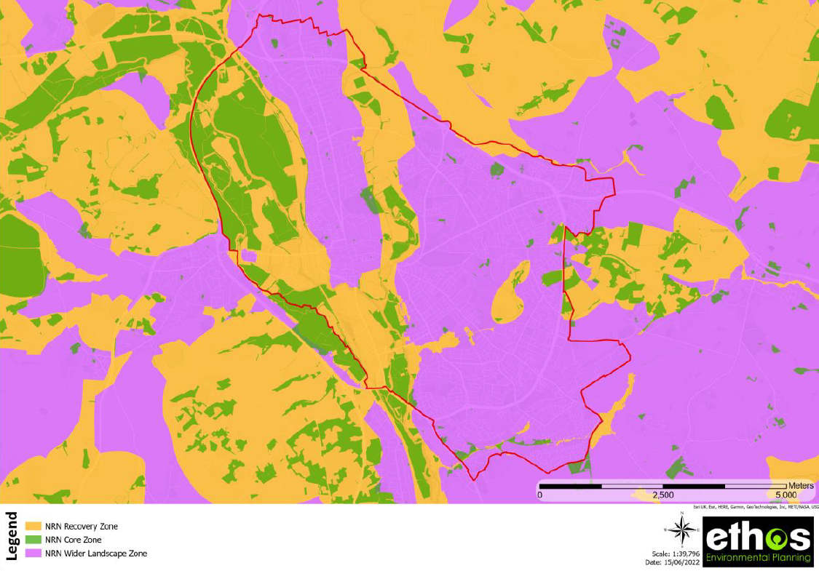
Figure 1.2: Oxfordshire Draft Nature Recovery Network mapping for the city illustrating key areas for biodiversity and areas for recovery which form a network across the county
1.17 Adapting to and building resilience to climate change is the other aspect of this theme and is essential because it can’t be prevented entirely. Green and blue infrastructure is a key feature that we can utilise in climate adaptation but the response to this global challenge will require other actions which the Local Plan strategy seeks to support. Taking a rigorous approach to flood risk in the city is important due to our being situated between two rivers, the canal and multiple brooks and streams that permeate Oxford. Therefore, ensuring that new development is guided by the analysis of current and future risk from all flooding sources as presented by the Environment Agency’s data and the Council’s Strategic Flood Risk Assessment mapping is vital to it being designed in a way that reduces risk as much as possible. Equally there are various other climate risks that new development will need to consider, principally, that of hotter and drier summers and the associated impacts of overheating and water stress that we expect to see as a result.

Oxford will be a city that utilises its resources with care, protects the air, water and soil and aims for net zero carbon

- Our city is ready for a net zero carbon future
- Our resources, including land, soil, water, and raw materials, are used prudently and with consideration of replenishment and renewal
- The city’s air quality and its impacts upon public health continues to improve
- The quality of natural resources is protected and human health is safeguarded.
1.18 As well as adapting to climate change, it is vital that every effort is made to ensure that new development in Oxford does not further exacerbate the changing climate. Actions which seek to reduce and prevent greenhouse gas emissions (climate change mitigation) will be important for contributing to achieving the UK’s legislated goals of being net zero by 2050 and limiting emissions in the nearer term in line with the sixth carbon budget. It is also essential for meeting the local target of being a net zero city by 2040, which Oxford set for itself in response to the declaration of a climate emergency in 2019.
1.19 The Local Plan is an important instrument in helping to deliver upon these targets. The strategy that guides the policies seeks to ensure that the way the city changes and grows as new development comes forward does so in a way that is as close to net zero carbon as possible. This means new development is energy efficient and meets all energy needs through renewables so that it does not require retro-fitting in future. It also means that where occupants of existing buildings seek to implement retro-fitting to improve energy efficiency and adaptation to climate change, the planning process is as supportive as possible to enable them to bring such improvements forward. These steps are vital for enabling the city to meet the challenging milestones lain out in the Zero Carbon Oxford Partnership (ZCOP) roadmap to net zero by 2040. Policies in the plan covering density of development, parking levels, reducing the need to travel and support for the provision of necessary infrastructure to achieve this are all important. The Local Plan also demonstrates support for county council policies that seek to deliver net zero targets.
1.20 Equally, however, the Local Plan is only one tool which will facilitate the shift to a net zero carbon city. Challenges such as the extensive retro-fit need across our building stock, the costs of implementing these, as well as the need for broad-scale upgrades and reinforcement of the energy grid to support wholescale electrification of heat and transport which will all support the implementation of the Plan’s policies will require wider solutions supported by a range of stakeholders and strategies to help address. There will also be an ongoing role for the City Council to work with partners through ZCOP and neighbouring authorities across the county to deliver on other related solutions to net zero that the Local Plan alone cannot fully address. For example, the delivery of new large-scale renewable energy projects will realistically be delivered outside of the city’s administrative boundaries and the city will focus on the smaller-scale renewables that can be accommodated within new developments across the city.
1.21 There are a range of natural resources in the city which are finite and so must not be wasted or polluted and the Local Plan includes policies to protect various aspects of the environment like soils and air. Equally, because land is a precious resource that needs to be used wisely, re-using land is very important, (particularly in helping to safeguard our most valued green spaces). In a city with such a history of development, this inevitably comes with risks of historic contamination which could put people and the environment at risk, so the Local Plan sets out policy that seeks to mitigate negative impacts and deliver remediation where necessary.
1.22 Pollution that stops ecosystems, and people, functioning well should be avoided, and planning policies have a role in this. Oxford has a variety of at-risk groups as well as areas of high biodiversity value that are often sensitive to pollution. Development must be managed to prevent harm. Air quality is already poor in parts of Oxford, and this can have significant negative impacts on health. Whilst the long-term expectation for the city is for overall air quality to continue to improve, we need to ensure that the impacts of new developments on the surrounding area, as well as on the users of new developments, are managed to ensure we continue on this path.

Oxford will be a city that respects its heritage and fosters design of the highest quality

- We have well-designed buildings and public spaces that feel safe, that are sustainable, and that are attractive to be in and travel to
- Our valued and important heritage will be protected and enhanced.
1.23 Oxford has a highly distinctive sense of place. Its built heritage reflects the way it has evolved over time, as a significant seat of learning, and as a seat of government. Industry has been important, with the factory of Morris Motors for example. Healthcare and developments in treatments have also been important in Oxford. Parts of Oxford were originally small rural settlements, and this history is still clear in its built form and interrelationship with green spaces. This heritage is reflected in the built environment and recorded in the archaeology, and the Local Plan sets out to continue to protect our most precious heritage assets, whilst also encouraging new development to take opportunities that would help enhance them.
1.24 The landscape setting of Oxford and its relationship with the built environment is of great significance. Oxford is recognised worldwide for its distinctive buildings, skyline of domes and ‘dreaming spires,’ set within a rural framework of interweaving rivers and meadows and contained by wooded ridges. The Oxford landscape consists, however, of more than these ‘iconic’ features and the evolution of the urban form, cultural associations, relationship of the public and private realms, the density and massing of buildings, the architectural dialogue and vitality, and the way humans have interacted with it through time all make an important contribution to the character of the city’s built-up areas. The Local Plan includes policies that seek to protect these important views and other important characteristics of Oxford, such as listed buildings, whilst helping to manage our changing city by ensuring that new development is high-quality and protects these special features so that they can be enjoyed by generations to come (e.g. HD1-4, HD7-9).
1.25 It is not only the historic environment that is significant in Oxford; there are many modern buildings of high quality and distinctive design that add to Oxford’s story. The Local Plan sets out the Council’s expectations for good design, building on the principles in the Government’s National Design Guide. Throughout the Plan, design guidance for applicants is provided at a range of levels, including through our heritage and design policies, as well as in the form of locally specific guidance within the Areas of Focus and on specific site allocations.
1.26 The broad approach requires that new development responds to the context of the city, adding to and enhancing it, being designed to suit what it is to be used for, to last, to fit its context and tell its own story. The Local Plan also stresses the importance of various sustainability principles as intrinsic to the design process, encouraging features that will make space for nature; that build resilience to climate change and help to secure net zero objectives (including retro-fitting of existing buildings).
1.27 The covid pandemic highlighted the importance of healthy internal and external spaces and setting standards for these has also guided our policies. Both outdoor spaces, but also the importance of space within the homes and offices in which we spend so much of our lives. The pandemic instilled a long-term change in the way many people use their homes, with added emphasis on its role as a space to work, to exercise, and to teach our children, which has added extra importance to policies which set standards for space and living environments.

Oxford will be a liveable city with strong communities and opportunities for all

- Our neighbourhoods will have the facilities we need to support our daily lives within a short walk from our homes, to support a liveable city.
- We will have thriving local centres that support a variety of uses and foster activity throughout the day and night.
- We continue in our role as a national and international destination for tourists and workers alike.
- We value diversity whilst fostering greater inclusivity within our communities.
- We support modal shift, to more sustainable/active forms of transport, including by limiting the need to travel, supporting good bicycle parking facilities and reducing on and off-street car parking where possible across the city.
1.28 The Covid pandemic highlighted the importance of our local areas and having access to various services and spaces on our doorstep. The benefit of having access to local amenities, like shops and pharmacies and open spaces in which to exercise and meet other people, without needing to rely upon a car, have become apparent for many. Yet this proximity is not always equal, and a lack of access to such spaces and facilities has become even more apparent for others.
1.29 Policies of the Plan aim to make sure Oxford is a liveable city. This means that there are thriving businesses and facilities in our local areas, that provide for the basis of daily needs and allow people easy access to things they need in their daily lives, including places to meet and socialise. Because of the accessibility and compactness of Oxford and that cycling for some people and for some trips is not practical, our focus is firstly on people being able to walk to a range of facilities. To have most of our shopping, jobs, health, socialising, and recreational needs within a short walk would not only reduce the negative impacts of future pandemics, but also promote healthier and more active lifestyles as well as reducing our impacts upon the climate and the natural environment alongside reduction in congestion and travel delays. Such functioning neighbourhoods offer the opportunity for communities to have a sense of belonging and help residents to feel more invested in their community.
1.30 Oxford city centre has a very particular role as a primary focus for a wide range of shopping, employment, leisure, education, and cultural activities, as well as being a major tourist destination, and it is vitally important to the overall success of Oxford. It draws visitors in from all over the city, the county, and much further afield. Managing visitors in a way that still enables a good visitor experience is important, so that the success of the centre is maintained, and facilities can thrive. It is important that there is the right mix of activities and attractive and accessible public realm for people to meet and linger and policies that direct these uses to the city centre and other centres are aimed at achieving this. Ensuring a city centre that is relevant to local residents is a key aspect of the City Centre Action Plan. The design principles set out in Policy C2 aim to manage to ensure the pressures on the city centre are well managed, and to maintain the attractiveness of the city centre (as well as the district centres).

Overarching threads

1.31 There are three particularly important threads which are wound throughout the Local Plan and supported by multiple policies across the different chapters. These relate to key issues and challenges facing the city which require a multi-faceted response and that cannot be separated neatly into any one of the six themes underpinning the vision. Some of the policies contribute to addressing these key issues directly, meanwhile, others have a more indirect but supporting role in addressing them.
1.32 The first thread is that of addressing climate change. In terms of reducing our emissions (climate change mitigation), the policies of chapter 5 most directly address this issue covering topics such as net zero development, embodied carbon and supporting retrofitting of existing buildings, however policies elsewhere in the Local Plan also address good urban design, parking, and bike storage which can enable people to live lower carbon lifestyles. Equally, a diverse range of policies can support adaptation and resilience to the expected impacts of climate change, from resilient design and construction (which includes concerns around overheating), to flooding, green infrastructure and most of these sits within chapter 4, though other policies such as urban design and health impact assessment will also contribute.
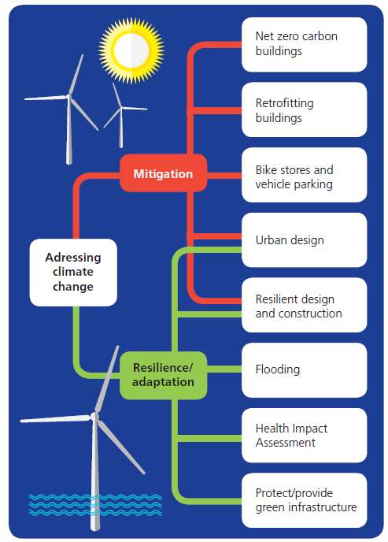
Figure 1.3: Key policies across the Local Plan which support the overarching thread of addressing climate change
1.33 The second overarching thread which various policies are trying to address is that of reducing inequalities in the city. The Local Plan chapter 2 has a range of requirements aimed at supporting access to affordable housing, as well as a good mix of housing, in order to help address housing inequality. Equally, chapter 3 sets out policies which seek to support the economy, including addressing unequal access to employment and training through options for policies requiring employment and skills plans as well as provision of affordable workspaces. Polices that relate to protecting, enhancing and providing new green infrastructure in chapter 4 are intended to help preserve access to and improve the natural environment across the city and there are other policies located in the document which also respond to this overarching thread.
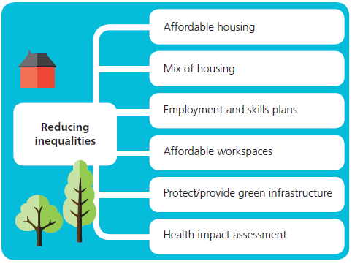
Figure 1.4: Key policies across the Local Plan which support the overarching thread of reducing inequalities

1.34 Meanwhile, the third overarching thread which runs throughout the document is that of liveable city and ensuring that residents have access to the basis of their daily needs within an easy walking distance of their homes. The Local Plan strategic policies discussed later in this chapter include an overarching spatial strategy which sets out where types of development ought to be focused in the city and helps support this theme. Within subsequent chapters, there are policies which focus on more specific aspects of provision that we want to see in our neighbourhoods to help ensure the right balance of needs are met. These include policies on town centre uses (chapter 3), the protection of a network of green spaces across the city (chapter 4), as well as policies which address the provision of community facilities (chapter 7).
GRAPHIC TO BE INSERTED
Figure 1.5: Key policies across the Local Plan which support the overarching thread of liveable city

Spatial Strategy and Presumption in Favour of Sustainable Development

The policies in the Local Plan seek to ensure that new development across the city occurs in the right place. To guide development to the optimum location, development proposals must reflect the key principles which support the spatial strategy.

Policies in the Plan will focus on delivering sustainable growth for Oxford that meets the aims to deliver affordable housing, to support an inclusive economy, to ensure the protection of our green and blue networks and natural resources and support the city in moving towards being net zero carbon by 2040.

Development should create strong sustainable cohesive and inclusive communities to support Oxford as a liveable city which makes the most effective and efficient use of land and enable a larger number of residents to access services, facilities and jobs locally.

When determining development proposals, the Council will take a positive approach that reflects the presumption in favour of sustainable development contained in the National Planning Policy Framework (NPPF). The Council will work proactively with applicants with the aim of finding solutions that mean that proposals can be approved wherever possible, to secure development that improves the economic, social and environmental conditions in the city.

Policy S1: Spatial Strategy and Presumption in Favour of Sustainable Development

Planning permission will be granted where development proposals accord with the policies of the Plan.

The City Council, through its policies and decisions, will aim to positively pursue sustainable development and achieve sustainable growth in the delivery of homes, jobs and services to create a network of healthy, well-connected, high-quality areas where people want to live, play, learn and work in line with the vision and objectives of the Local Plan. To help achieve this it will aim to ensure development is located to:
- ensure the continued strength and vibrancy district and local centres so they continue to attract people and support a range of facilities that meet people’s immediate needs conveniently within their local area;
- ensure new development is focussed on areas with opportunities for sustainable travel links;
- ensure activities that attract large numbers of people are centrally located in the city centre and district centres, so they are easy to reach by walking, cycling and public transport;
- focus new employment development that supports Oxford’s national and international role in research and development on existing sites already in that use, prioritising housing elsewhere;
- ensure new uses are in locations where they will not harm the amenity of existing neighbouring uses; and
- prevent new development in locations where it would damage important blue and green infrastructure networks, public open space, and flood plain.

When determining development proposals, the Council will take a positive approach that reflects the presumption in favour of sustainable development contained in the National Planning Policy Framework (NPPF). The Council will work proactively with applicants with the aim of finding solutions that mean that proposals can be approved wherever possible, to secure development that improves the economic, social and environmental conditions in the city.

All new proposals for development must conform with the principles of securing sustainable development, which ensures that the city is ready for a net zero carbon future, natural resources and raw materials are used prudently and considerately, the air quality of the city is improved, and human health is safeguarded.

Planning applications that accord with the policies in this Local Plan (and, where relevant, with policies in any neighbourhood plans adopted in the future) will be approved without delay, unless material considerations indicate otherwise.

Where there are no policies relevant to the application or relevant policies are out of date at the time of making the decision, then the Council will grant permission unless material considerations indicate otherwise, considering whether:
- the application of policies in the National Planning Policy Framework that protect areas or assets of particular importance provides a clear reason for refusing the development proposed; or
- any adverse impacts of granting permission would significantly and demonstrably outweigh the benefits, when assessed against the policies in the National Planning Policy Framework taken as a whole

Design Code and Guidance

Good design is a fundamental part of achieving many of the aims of the Plan. Good design is not just about creating aesthetically pleasing buildings. It is about placemaking, strengthening the connection between people and the places they share, promoting a sense of identity and people’s health and well-being.
Oxford’s heritage is a unique and irreplaceable resource, which has a fundamental role in shaping the city’s character and cultural offer. The City Council is committed to preparing, reviewing, and adopting as appropriate) conservation area appraisal and management plans, as well as other evidence base documents to help further understanding of the significance and benefits of our heritage assets.
Good design will also need to support the protection and enhancement of our natural environment for the many benefits it provides. This means ensuring that the design of the built environment factors in spaces for nature and wildlife, as well as green features which perform multiple functions that support people’s wellbeing, such as providing spaces to socialise and get closer to nature, promoting cooling during hot weather and flood retention during heavy rainfall. Fundamental to good design is also the transition to net zero carbon development. This means encouraging a range of measures that secure energy efficiency and energy generation so that our buildings operate without adding to greenhouse gas emissions, are constructed in ways that use natural resources prudently and enable future occupants to travel and live in ways that can help them to reduce their carbon footprint.
Design should be a collaborative process. The community has been consulted during the creation of this local plan, including through a workshop led by Design South East that has informed the development principles in the Marston Road and Old Road Area of Focus. Supporting documents will be developed with community collaboration where these would be helpful. The Botley Retail Park Development Brief 2022 and the West End and Osney Mead Supplementary Planning Document (SPD) set out guidance for these two areas.

Policy S2: Design Code and Guidance

The design checklist set out in Appendix 1.1 and expanded on in the Design Code document should be used inform design and ensure that a comprehensive approach is taken from the outset, which includes consideration of the relevant context including heritage, promotion of healthy lifestyles, and protection of the natural environment.

For Areas of Focus, the City Centre and District Centres, and other areas with more detailed guidance, proposals should refer to and align with the design principles set out in the Local Plan or in supporting documents such as the West End and Osney Mead Supplementary Planning Document and the Botley Road Retail Park Development Brief 2022. The City Council will be proactive in producing additional local design codes or guidance when a need arises (such as the Botley Design Guide), involving the local community and landowners, and will support neighbourhood planning groups who wish to produce design guidance for their areas.

In recognition of the significance of Oxford’s heritage, and as part of its positive approach to the historic environment, in addition to fulfilling its statutory duties, the Council will:
- identify, conserve and enhance local heritage assets
- take a proactive approach to the protection, promotion and interpretation of the city’s archaeological remains
- support the conservation and appreciation of key characteristics of the wider townscape and landscape
- take a positive strategy towards assets that are considered at risk.

Infrastructure Delivery in New Developments

To deliver the Local Plan vision for 2040, the spatial strategy and plan objectives, the provision of infrastructure will need to be funded and delivered in a timely manner to support development. It is important to ensure that roads, local services and facilities can cope with the increased demand resulting from development proposed in the Plan.

Where new development creates a need for new and improved infrastructure, contributions from developers and delivery of infrastructure will be sought to make the development acceptable in planning terms. These may be delivered as part of a Section 106 (S106) agreement, a S278 agreement, or through Community Infrastructure Levy (CIL) funds.

The cumulative impact of individual applications may be considered when assessing infrastructure requirements, taking account of other planning contributions (such as affordable housing). Contributions from a particular development must be fairly and reasonably related in scale and kind to the contribution to the cumulative impact from the relevant scheme; and if necessary, address any unacceptable short-term problems.

The Community Infrastructure Levy (CIL) is a tariff in the form of a standard charge on development, which Oxford, as a CIL Charging Authority, sets to help the funding of infrastructure. The principle behind CIL is for those who benefit financially from a planning permission to pay towards the cost of funding infrastructure needed to support development. Since most development has some impact on infrastructure, it follows that it should contribute to the cost of providing or improving infrastructure.

The City’s current infrastructure requirements can be found in the Infrastructure Delivery Plan (IDP) which includes an Infrastructure Delivery Schedule which highlights key infrastructure needed to support the Local Plan to 2040. The IDP includes key infrastructure projects for transport and physical infrastructure; social and community facilities and green infrastructure to support the city’s planned development needs to 2040. The IDP forms part of the evidence base and is a ‘live’ document that is regularly updated.

The delivery of certain infrastructure projects is considered to have wide-reaching improvements and benefits that could be transformational in nature. This includes the county council’s core schemes involving the introduction of traffic filters and workplace parking levy. The two rail two projects that have this potential which could be delivered in Oxford within the plan period to 2040. These are the transformation of Oxford Railway Station (incorporating the delivery of East-West Rail), and the re-opening of the Cowley Branch Line (CBL) to passenger trains (and the delivery of stations to service key employment sites in the south of the city such as the Oxford Science Park and Oxford Business Park (now known as ARC Oxford)). These projects would increase the accessibility of these locations to a wider workforce across the Oxford to Cambridge Pan Regional Partnership area. It is likely that significant funding will be required to deliver these transformational opportunities and certain sites that lie within the Cowley Branch Line and Littlemore Area of Focus (Policy CBLLAoF) will be expected to help contribute to their delivery.

Policy S3: Infrastructure Delivery in New Development

The Council will work with infrastructure providers, developers and other key stakeholders to support the delivery of the infrastructure necessary to enable the development set out in the Local Plan. The projects required to support the Local Plan strategy are identified within the Infrastructure Delivery Plan. The Infrastructure Delivery Plan will be updated to ensure infrastructure information remains up to date and is monitored effectively.

Developers will be expected to engage early with the Council and infrastructure service providers to discuss their requirements. Developers must demonstrate they have explored existing infrastructure capacity, and how this could be future-proofed, with appropriate providers and demonstrate that they have made sufficient provision. Where appropriate, and where there is an identified shortfall across the city, opportunities should be taken to maximise infrastructure provision on suitable sites.

Development proposals, including those allocated in this plan which give rise to a need for infrastructure improvements, will be expected to mitigate their impact, both individually and cumulatively, and at a rate and scale to meet the needs that arise from that development or a phase of that development. The standards of infrastructure delivery will be expected to comply with other policies set out within this Plan.

Planning permission will be granted subject to the provision of (or appropriate funding towards) the required level of infrastructure to support the development. Infrastructure identified within the Infrastructure Delivery Plan or through negotiations on individual planning applications will continue to be delivered either through on-site provision or off-site contributions and secured by S106, S278 or other appropriate agreements and the Community Infrastructure Levy (CIL) or its successor as well as other identified sources of funding as set out in the Infrastructure Delivery Plan.

Development proposals which rely on the delivery of critical infrastructure projects to support the development, will only be permitted prior to completion of that project or where appropriate, a phase of that project which has been identified as necessary in the IDP, where the council is content that the infrastructure or phase of that infrastructure will be in place within a reasonable timetable from the date of permission.

Proposals to enhance the City’s rail and bus network will be supported. In particular, the redevelopment of Oxford Station and additional rail capacity to accommodate services including opening of the Cowley Branch Line (CBL) for passengers. Proposals for improvements to Oxford Railway Station that increase network capacity, improve the design and quality of facilities and interchange and support the CBL will be supported.
Enhancements to public transport accessibility in the south east of the city are needed to support the anticipated intensification of existing employment uses and new residential development. Supporting existing public transport and the reopening of the CBL to passengers would enable a reduction in car use to this area. Financial contributions from new development within a 1,500m buffer zone of the proposed CBL stations will be expected in order to achieve public transport enhancements in this area, including among other sustainable transport measures the delivery of the CBL.

Plan Viability
The Plan needs to deliver development that is viable, and the Local Plan viability study has informed the drafting of the policies. However, in some instances a site faces exceptional costs that could not have been anticipated in the whole plan viability assessment. Setting out the basis for negotiations relating to viability as part of the Plan helps to be clear on priorities and expectations for evidence.
It is anticipated that some new development proposals will have exceptional costs owing to the site conditions, for example land contamination which requires remediation, or transport or educational infrastructure. Assessing these costs is challenging until proper site investigations have been undertaken and we are aware such situations have implications for site viability. In these circumstances, policies in the plan which have the greatest potential impacts upon site viability will need to be considered in combination to ensure that site is deliverable over the Plan period. Policies that are likely to have the greatest impact on viability include the parking policy C8, net zero buildings in operation Policy R1, or the affordable housing policy H2.
Where the combined impact of the policies in the Plan results in a site being unable to deliver a viable development because of a site-specific circumstance, development should proceed in a way that ensures maximum compliance with planning policies. The intention of Policy S3 is guide the process of making amendments to proposals to ensure viability, so that the intention of the policies is met as far as possible. Affordable housing is prioritised in this approach. The policies identified as being most impactful on viability will not apply in all cases. Negotiations will proceed on a case-by-case basis, but the Council will expect the retention of affordable housing delivery to be prioritised over other policy considerations. The City Council will work with applicants to understand where the largest costs savings can be made in terms of items that may trigger non-compliance with policy (such as energy offsetting or parking) and will weigh up the planning (and public interest) merits of doing so but will actively engage with developers before any negotiation is undertaken.

Policy S4: Plan Viability

The policies in the Plan should not generally result in a development proposal becoming unviable. If the combined impact of the policies in the Plan do result in a site being unable to deliver a viable development and if an applicant can demonstrate particular circumstances that justify the need for a viability assessment, negotiations will take place informed by an open book exercise. If the applicant can demonstrate the development to be unviable, a cascade approach should be worked through with the City Council until development is viable, looking at first any carbon offsetting, then any low parking and finally affordable housing

The City Council will always expect developers to have considered the financial implications of affordable housing policy requirements, and local market indicators, when purchasing the land for development.

Where it is clearly demonstrated that any offsetting money against the targets in Policy R1 Net Zero Buildings in Operation cannot be fully achieved t, payments towards energy offsetting should be reduced incrementally until viability is achieved. The development itself must remain free of fossil fuel use to ensure that it is net zero carbon ready and does not conflict with Net Zero Carbon targets for the city and nationally.

If the development remains unviable and the low car requirement in the parking policy impacts upon site viability, then this must be clearly set out in the planning application, including setting out the site-specific circumstances that lead to it being unviable. In the first instance, allocating spaces to units should be considered. If the development is still not viable, increasing the number of spaces incrementally, up to the maximum parking standards, which will be no more than one space per unit for residential schemes.

If, following the above adjustments to achieve viability, the affordable housing policy is impacting upon site viability, then the following steps in the cascade should be followed:

Affordable housing viability cascade

If on relevant sites (of 10 or more units) it can be robustly proven that meeting the affordable housing policy will make a site unviable, developers and the City Council will work through a cascade approach in the following order until a scheme is made viable.

This cascade seeks to prioritise provision of social rent:

- firstly, reduce the number of affordable housing units provided by reducing the intermediate housing element only whilst retaining the social rent element in full;
- secondly, if the development is still not viable, continue to reduce the amount of social rent incrementally until viable.

Robust evidence must be in the form of an independent viability appraisal. The City Council will expect the developer to negotiate on an “open book” basis which relates to the particular site circumstances that have resulted in the development’s non-viability.

Based on 2022 house price and salary data from: House price to residence-based earnings ratio - Office for National Statistics (ons.gov.uk)
Based on March 2023 median rental price figures from: Private rental market summary statistics in England - Office for National Statistics (ons.gov.uk)
Oxfordshire Local Investment Strategy (LIS) (July 2019) https://www.oxfordshirelep.com/lis

